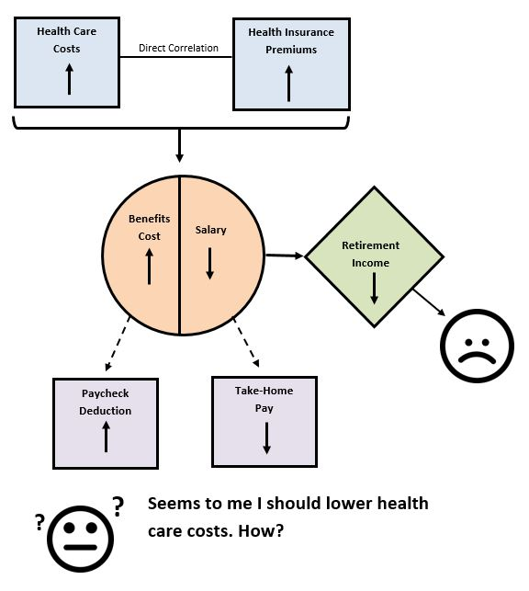

1. **Healthy Habits**
2. **Preventive Services**
3. **Cost Estimating Tools**
4. **Condition Management**
5. **Selecting the Appropriate Care**

**Rising Health Care Costs**

**What does it mean?**